**Requirement plan**

Admission system

**Contents**

List of table 2

1. Revision 3

2. Introduction 4

3. Requirement Management Plan 4

3.1 Roles and Responsibility 4

3.2 Requirement Schedule 5

4. Tools, Environments and Infrastructure 7

5. Document Template 8

# **List of table**

Table 1: Revision history 3

Table 2: Stage 1 description 5

Table 3: Roles and responsibility in stage 1 6

Table 4: Stage 2 description 7

Table 5: Roles and responsibility in stage 2 7

Table 6: Requirement Schedule 8

# **Revision**

|  |  |  |  |  |
| --- | --- | --- | --- | --- |
| **No** | **Version** | **Update date** | **Author** | **Content** |
| 1 | 0.1 | 18/11/2013 | Khang Huynh | Create Requirement plan document |
| 2 | 0.2 | 19/11/2013 | Khang Huynh | Update Template |
| 3 | 0.3 | 20/11/2013 | Khang Huynh | Update Requirement Schedule |
| 4 | 0.4 | 23/11/2013 | Khang Huynh | Update process, description, roles and reponsibility |
| 5 | 0.5 | 26/11/2013 | Khang Huynh | Update detail roles for Stage 1,2  Update requirement schedule. |

Table 1: Revision history

# **Introduction**

The purpose of the Requirements Management Plan is to define the roles and responsibility of team member in requirement processes, define schedule and procedures to be used by the Deadline Team.

# **Stage 1**

## 3.1 Stage 1 Process

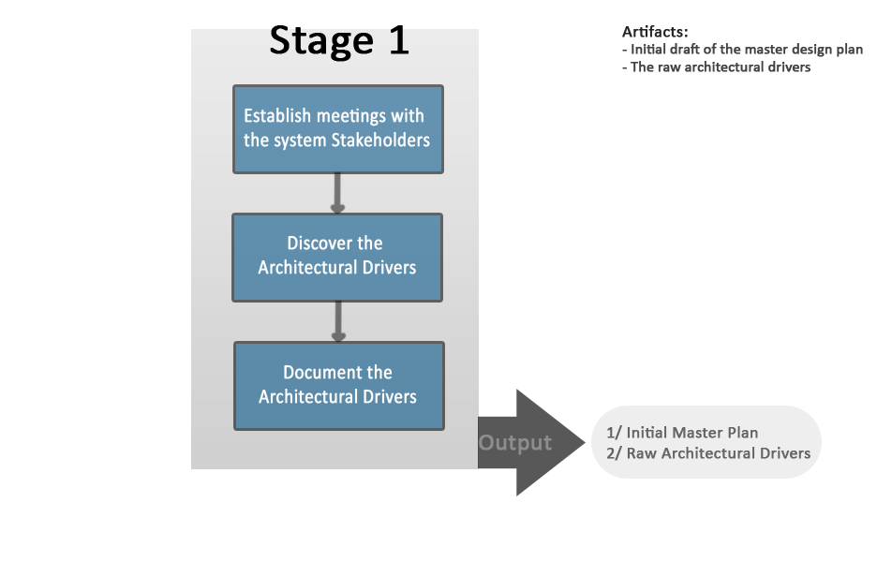

## 3.2 Stage 1 Description

|  |  |  |
| --- | --- | --- |
| No | Activities | Description |
| 1 | Establish meetings with the system Stakeholders | Establish the encounters between stakeholders and the architectural design team are structured to make the most efficient use of valuable time spent with the stakeholders. |
| 2 | Discover Architectural Drivers | Gathering as much information about what the stakeholders need and expect in the system. Gathering as much information as possible regarding the system architectural drivers to include high-level functional requirements, business constraints, technical constraints, and quality attributes. |
| 3 | Document the Architectural Drivers | Document and uses templates designed to capture information about the system architectural drivers include high-level functional requirements, business constraints, technical constraints and quality attributes. |

Table 2: Stage 1 description

## 3.3 Roles and Responsibility

|  |  |  |
| --- | --- | --- |
| **Role** |  | **Stage 1 recommended responsibility** |
| Customer | Quang Nguyen | The customer is responsible for defining and approving all requirements, and all modification to requirements. |
| Managing engineer | Huy Ngo | - Create the initial master design plan  - Assist the requirements engineer in planning the architecture drivers elicitation  - Track efforts  - Update and replan master design plan based on actual data |
| Chief Architect | Phu Ta | - Make questions to gather requirement (focus on functional requirement).  - Focus on eliciting complete and measureable architecture drivers  - Assist the requirements engineering in capturing and documenting to collection of raw architecture drivers. |
| Chief scientist | Dao Khau | - Make question to gather requirement (focus on technical and quality attribute issues associated with eliciting the architectural drivers).  - Describes quality scenario. |
| Requirements Engineer | Khang Huynh | - Plan, coordinate, and gathering initial requirement the stage 1.  - Writing the operation requirement  - Coordinate architectural drivers consolidation meetings.  - Communication with customer to validate requirements.  - Make questions to gather requirement (focus on scope project). |
| Quality process engineer | Huy Nguyen | - Ensure that the Stage 1 are being followed.  - Make questions to gather requirement (focus on business constraint and quality attribute). |
| Support engineer | Chau Le | - Install, configure, and maintain the tools necessary to support stage 1 activities and any tools that can be established now to support the remainder of the project.  - Describes technical constraint. |
| Production engineers | All Team | - Assist the team in the elicitation, capture, review and documentation of architectural drivers engineers. |

Table 3: Roles and responsibility in stage 1

# **Stage 2**

## 4.1 Stage 2 Process

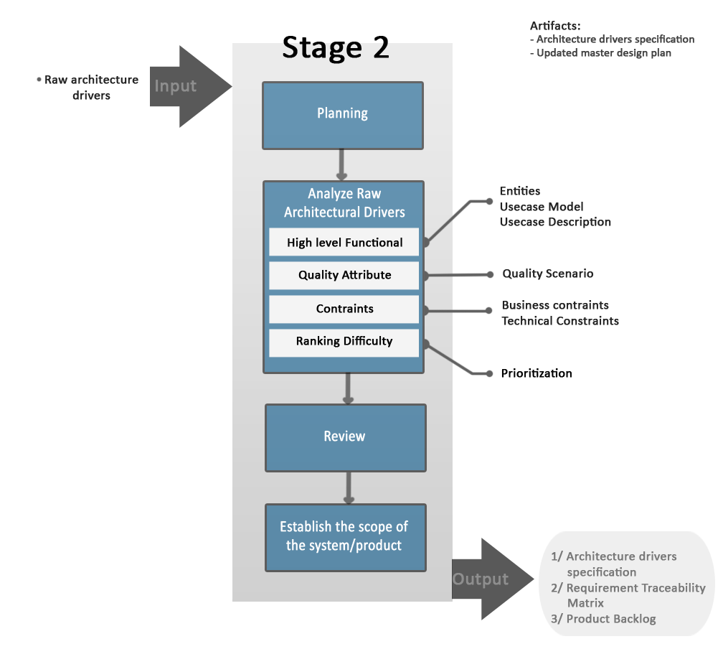

## 4.2 Stage 2 Description

|  |  |  |
| --- | --- | --- |
| **No** | **Activities** | **Description** |
| 1 | Planning | Planning the activities of the stage and updating the master design plan to reflect the time that the architecture design team estimates they will take in stage 2. |
| 2 | Analyze Raw Architecture Drivers | Analyze the consolidated raw architecture drivers information gathered in stage 1 to clarify and refine the architectural drivers |
| 3 | Review | After the architecture drivers specification is complete must review and formally accepted by the stakeholders. |
| 4 | Establish the scope of the system/product | Establish the scope, context, and size of the development effort. |

Table 4: Stage 2 description

## 4.2 Roles and responsibility

|  |  |  |
| --- | --- | --- |
| **Role** |  | **Stage 1 recommended responsibility** |
| Customer | Quang Nguyen | The customer is responsible for defining and approving all requirements, and all modification to requirements. |
| Managing engineer | Huy Ngo | - Plan, coordinate, track, and oversee stage 2 activities. |
| Chief Architect | Phu Ta | - Lead the analysis of the consolidated raw architectural drivers.  - Describes quality scenario. |
| Chief scientist | Dao Khau | - Assist in the analysis of the consolidated raw architectural drivers and focus on technical issues, especially  - Identifying early technical risks associated with the raw architectural drivers.  - Describes use case detail. |
| Requirements Engineer | Khang Huynh | - Responsible for writing the architecture drivers specification document  - Communication with customer to validate requirements. |
| Quality process engineer | Huy Nguyen | - Ensure that the Stage 2 are being followed.  - Describes use case detail. |
| Support engineer | Chau Le | - Assist with analysis of consolidated raw architectural drivers and writing the architecture drivers specification document as necessary.  - Describes use case detail. |
| Production engineers | All Team | - Analysis requirement. |

Table 5: Roles and responsibility in stage 2

# Requirement Schedule

|  |  |  |  |  |  |
| --- | --- | --- | --- | --- | --- |
| **No.** | **Activities** | **Start** | **End** | **Human Resource** | **Stage** |
| 1 | Discover Architectural Drivers.  + Functional  + Quality Attribute  + Constraints | 26/11/2013 | 26/12/2013 | All Team | Stage 1 |
| 2 | Create Operation Requirement Document. | 26/11/2013 | 26/12/2013 | Khang Huynh |
| 3 | Meeting with customer #1  - Elicit requirements high level and quality attribute  + Compose newsletter module  + Catalog module  + Question and Answer module  - Constraints: technical and business | 28/11/2013 | 28/11/2013 | All Team |
| 4 | Update Operation Requirement Document.  + Functional  + Quality Attribute  *<send for customer review>* | 28/11/2013 | 29/11/2013 | All Team |
| 5 | Meeting with customer #2.  + Review entities and continues elicit high level functional and quality attributes | 3/12/2013 | 3/12/2013 | All Team | Stage 2 |
| 6 | Update Operation Requirement Document  Create Architecture Drivers Specification  + Entities  + Use case diagram | 3/12/2013 | 5/12/2013 | All Team |
| 7 | Meeting with mentor #2 to review works done at requirement stages | 5/12/2013 | 5/12/2013 | All Team |
| 8 | Update Architectural Drivers Specification  + Use case diagram  + Use case description  + Quality Attribute scenarios  *<send for customer review>* | 5/12/2013 | 10/12/2013 | All Team |
| 9 | Meeting with mentor #3 to review works done at requirement stages | 12/12/2013 | 12/12/2013 | All Team |
| 10 | Review with customer #3.  + Use case diagram  + Use case description  + Quality Attribute scenarios | 12/12/2013 | 12/12/2013 | All Team |
| 11 | Update Architectural Drivers Specification *<Requirement changes>*  + Entities  + Use case diagram & description | 12/12/2013 | 14/12/2013 | All Team |
| 12 | Review Architectural Drivers Specification with team members  *<send for customer review>* | 14/12/2013 | 14/12/2013 | Khang Huynh |
| 13 | Meeting with customer #4  + Review entities, use case diagram and description only | 17/12/2013 | 17/12/2013 | All Team |
| 14 | Update Entities and use case diagram and description  *<sent for customer approved>* | 17/12/2013 | 19/12/2013 | All Team |
| 15 | Meeting with mentor #4 to review works done at requirement stages | 19/12/2013 | 19/12/2013 | All Team |
| 16 | Continues update and analyze  + Quality attributes scenarios  + Technical/business constraints | 19/12/2013 | 21/12/2013 | All Team |
| 17 | Review Architectural Drivers Specification with team members  *<send for customer review>* | 21/12/2013 | 21/12/2013 |  |
| 18 | Meeting with customer #5  + Review Quality attribute and constraints  + Define prioritization | 24/12/2013 | 24/12/2013 | All Team |
| 19 | Update whole architectural drivers specification document  *<sent for customer approved>* | 24/12/2013 | 24/12/2013 | All Team |
| 20 | Establish Project Scope.  Review customer, mentor & closed architecture drivers specification | 26/12/2013 | 26/12/2013 | All Team |  |
| 21 | Get detail requirements for Spring 1 | 20/1/2013 |  | All Team | Spring 1 |

Table 6: Requirement Schedule

# **Tools, Environments and Infrastructure**

Excel 2010 and Word 2010 will be used for developing requirement documents.

Visio 2010 will be used for developing use case diagram.

Gmail will be used for communicate with customer.

TortoiseSVN will be used for saved document.

# **Document Template**

Operational Requirement Document – Template.

Architecture Drivers Specification – Template.